TASK-2

TITLE: Design a FIR Filter
AIM: To design and simulate a 4-tap Digital FIR (Finite Impulse Response) filter using Verilog HDL and verify its functionality through simulation results.
OBJECTIVE:1. To understand FIR filter architecture.
2. To implement FIR filtering using Verilog HDL.
3. To perform simulation and analyze filter output.
4. To study delay elements, multipliers, and adders used in FIR filters.
SOFTWARE USED: vivado
THEORY:
A FIR (Finite Impulse Response) Filter is a digital filter whose output depends only on present and previous input samples.
The general FIR filter equation is:
y(n)=$\sum_{k=0}^{N-1}{h\left(k\right)x(n-k)}$
Where:
y(n) = Output signal
x(n) = Input signal
h(k) = Filter coefficients
N = Number of taps
In FIR filters:
1.The output becomes stable after finite clock cycles.
2.FIR filters are always stable.
3.They are widely used in DSP, communication systems, and noise reduction applications.

CODE:
VERILOG CODE FIR FILTER :
`timescale 1ns / 1ps
///finite impluse response (FIR) filter
module fir_filter(
input clk,
input reset,
input signed [7:0] x,
output reg signed [15:0] y
);

parameter h0 = 1;
parameter h1 = 2;
parameter h2 = 3;
parameter h3 = 4;

reg signed [7:0] d0, d1, d2, d3;

always @(posedge clk or posedge reset)
begin
if(reset)
begin
d0 <= 0;
d1 <= 0;
d2 <= 0;
d3 <= 0;
y <= 0;
end

else
begin
d3 <= d2;
d2 <= d1;
d1 <= d0;
d0 <= x;

y <= (h0*d0) + (h1*d1) + (h2*d2) + (h3*d3);
end
end

endmodule
TESTBENCH FOR THAT VERILOG CODE:
`timescale 1ns / 1ps
///testbench
module fir_filter_tb;

reg clk;
reg reset;
reg signed [7:0] x;
wire signed [15:0] y;

fir_filter uut(
.clk(clk),
.reset(reset),
.x(x),
.y(y)
);

always #5 clk = ~clk;

initial
begin
clk = 0;
reset = 1;
x = 0;

#10 reset = 0;

#10 x = 1;
#10 x = 2;
#10 x = 3;
#10 x = 4;
#10 x = 5;
#10 x = 6;
#10 x = 7;
#10 x = 8;

#50 $finish;
end

initial
begin
$monitor("Time=%0t Input=%d Output=%d", $time, x, y);
end

endmodule
PRACTICAL OUTPUT:
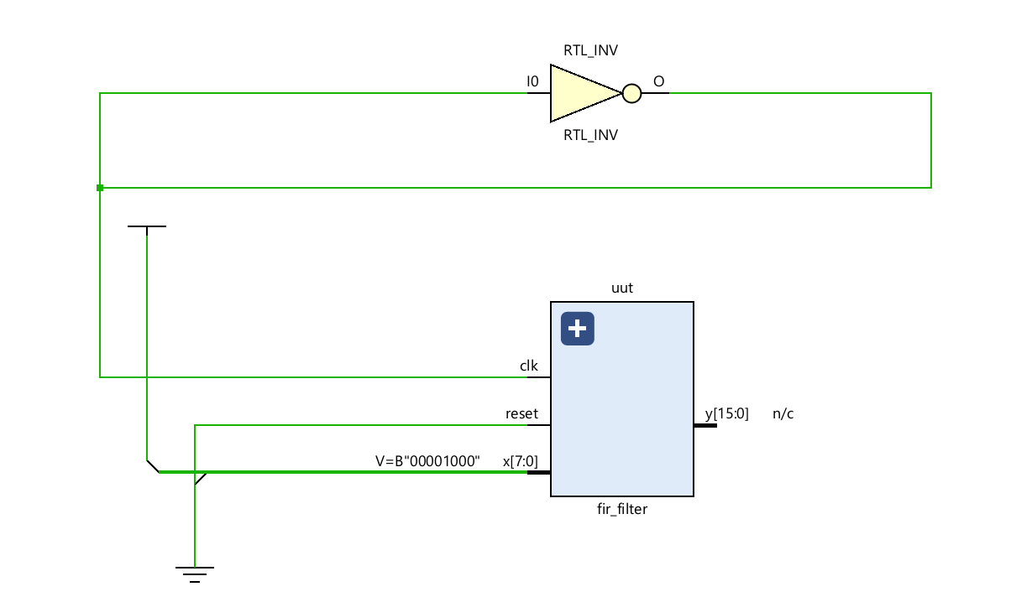
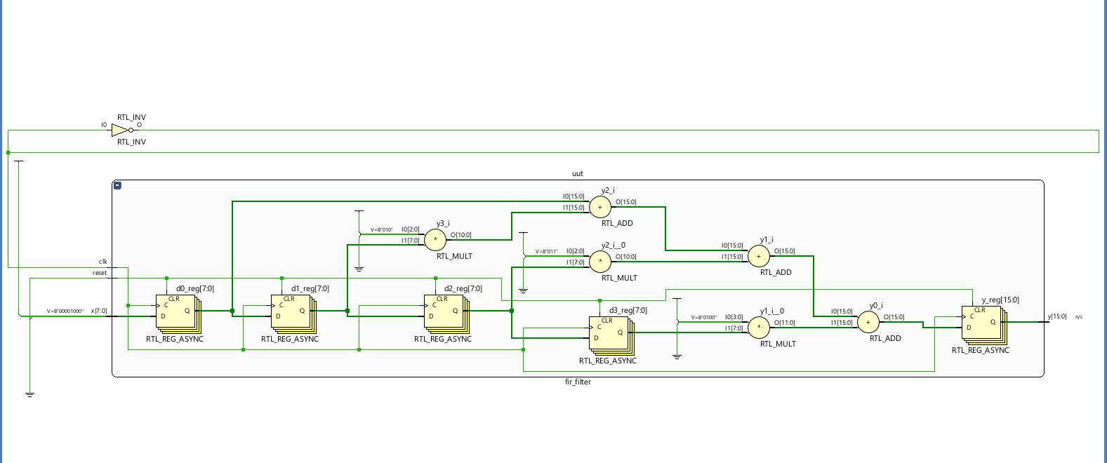
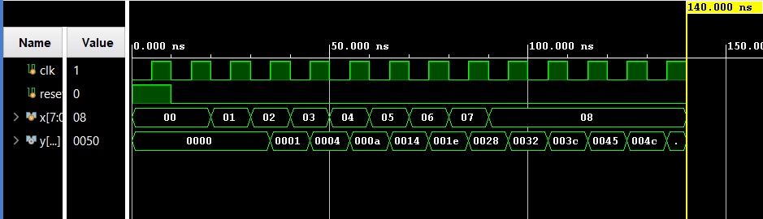
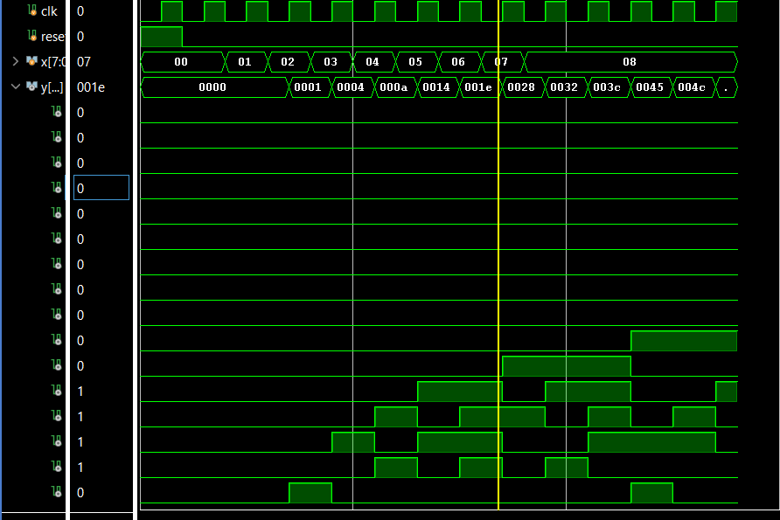
PERFORMANCE ANALYSIS:
Parameter | Observation
Filter type | FIR filter
Number of taps | 4
stability | Stable
speed | High
Hardware complexity | Moderate
Output response | Finite duration

CONCLUSION:
The Digital FIR Filter was successfully designed and simulated using Verilog HDL. The simulation results verified correct filtering operation based on input samples and filter coefficients. The project helped in understanding FIR architecture, delay elements, and DSP-based digital filter implementation

